1. Console "Hello Word" in document.ready function

Ans == <https://github.com/pranav0297/jquery/blob/master/jquery1.html>

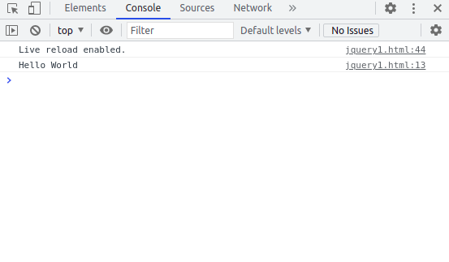

1. Select a ID name "#test" and add class "load" when DOM is loaded

Ans == <https://github.com/pranav0297/jquery/blob/master/jquery2.html>

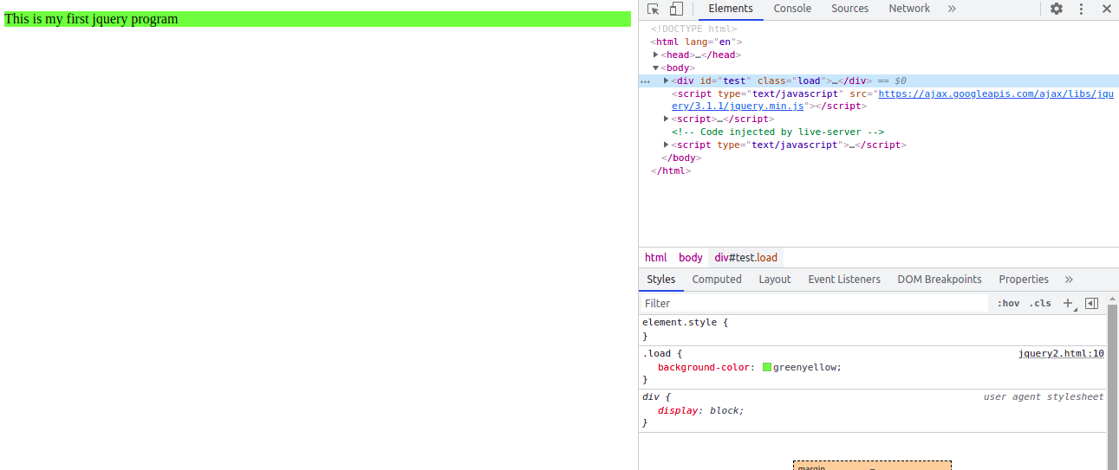

1. Change the color of element which class name end with "-new"

Ans == <https://github.com/pranav0297/jquery/blob/master/jquery3.html>

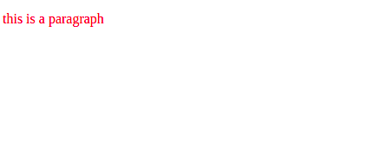

1. Disable submit button using jquery attr method

Ans == <https://github.com/pranav0297/jquery/blob/master/jquery4.html>

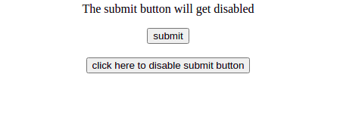

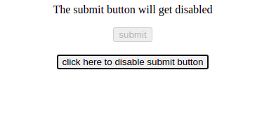

1. Change the font size of ".target" which has parent element with id name "#main"

Ans == <https://github.com/pranav0297/jquery/blob/master/jquery5.html>

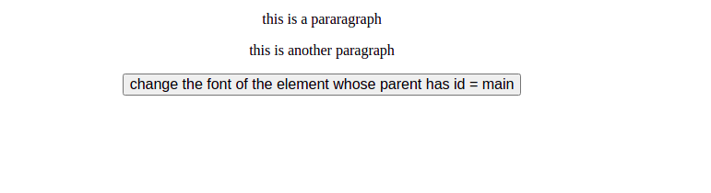

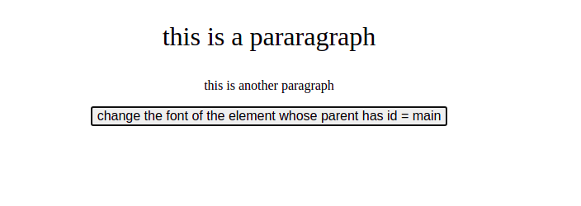

1. After page load change the HTML of div element with "p" element

Ans == <https://github.com/pranav0297/jquery/blob/master/jquery6.html>

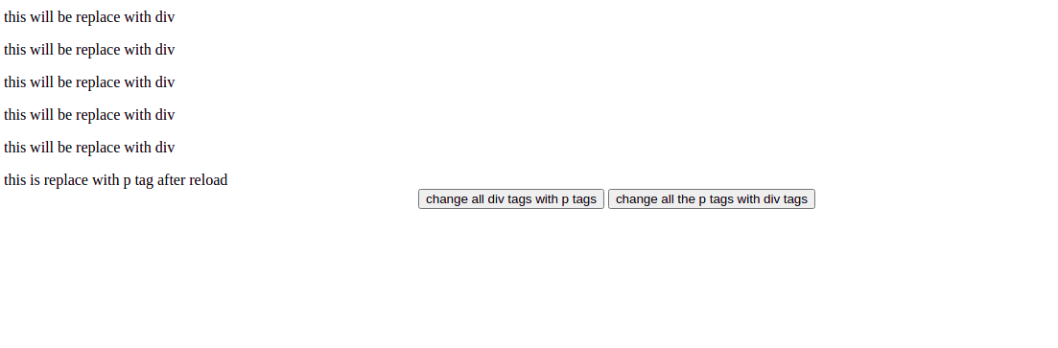

1. Bind a click function to an "click" element and append next "click" next to it.

Ans == <https://github.com/pranav0297/jquery/blob/master/jquery7.html>

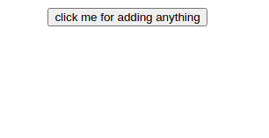

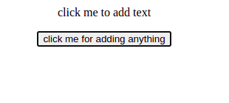

1. Click event not working on element which added dynamicly or via script, make it work using .on method

Ans == <https://github.com/pranav0297/jquery/blob/master/jquery8.html>





1. Get dropdown selected value on onchanage event and append in div container

Ans == <https://github.com/pranav0297/jquery/blob/master/jquery9.html>

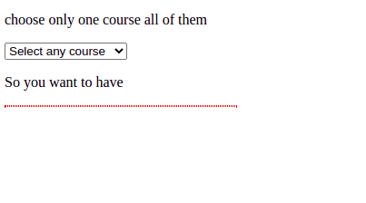

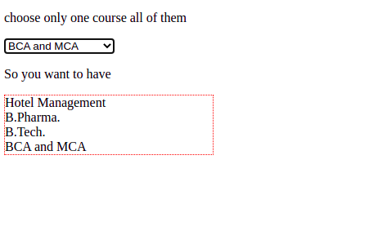

1. Create a dropdown menu using hover method in jquery

Ans == <https://github.com/pranav0297/jquery/blob/master/jquery10.html>

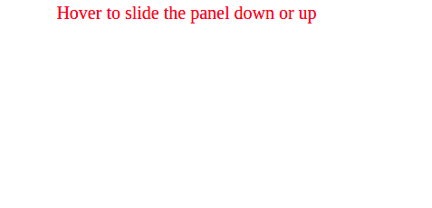

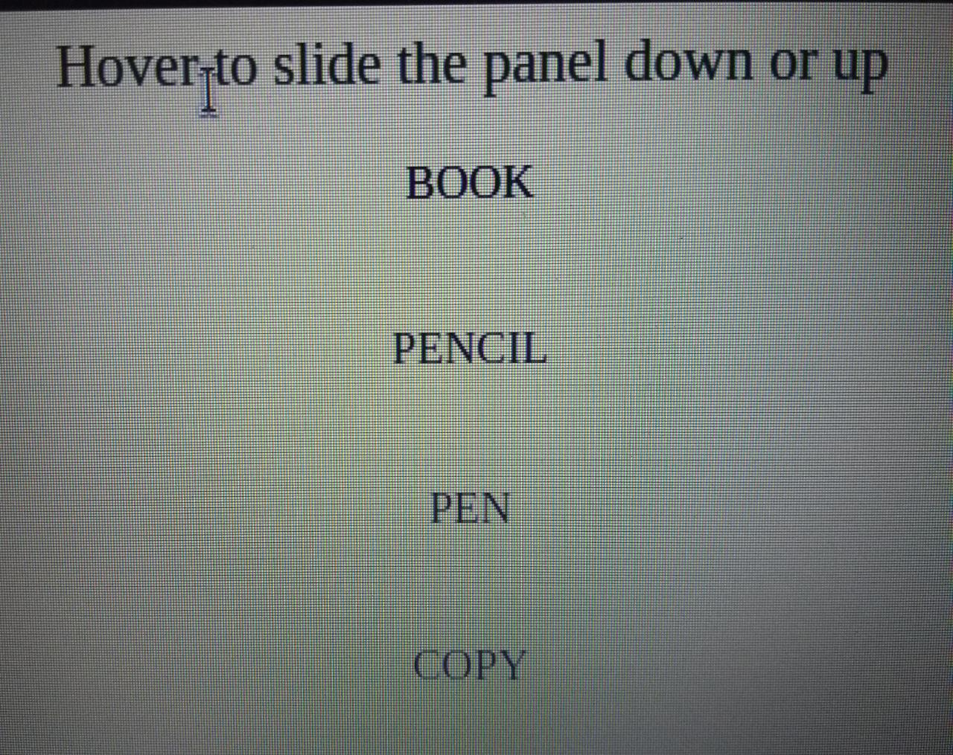

1. On clicking on "[google](https://www.google.com/)" tag. It is taking us to google home page. Stop it from happening.

Ans == <https://github.com/pranav0297/jquery/blob/master/jquery11.html>

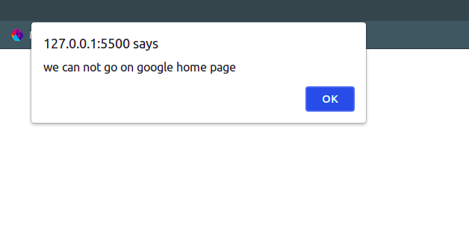

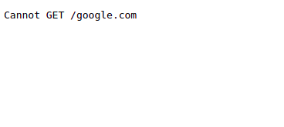

1. We have bind a click funtion to parent div but we want stop it from performing when user clicks on its child li

Ans == <https://github.com/pranav0297/jquery/blob/master/jquery12.html>

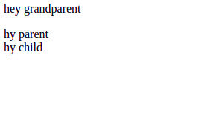

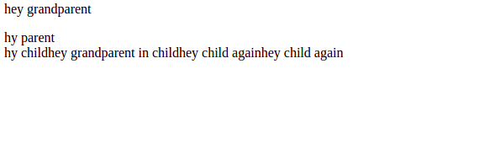

1. Get the max height of elements using jquery each method

Ans == <https://github.com/pranav0297/jquery/blob/master/jquery13.html>

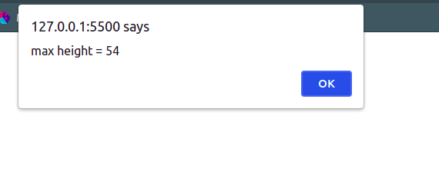

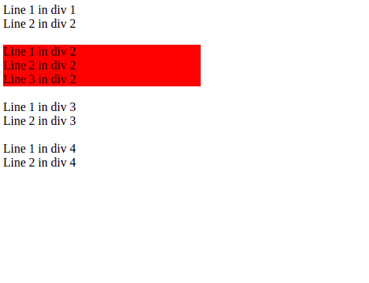

1. Chagne color of every cell which has numberl larger than 10.

Ans == <https://github.com/pranav0297/jquery/blob/master/jquery14.html>

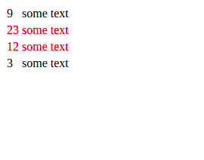

1. Retrive the data from server using ajax get call

Ans == <https://github.com/pranav0297/jquery/blob/master/jquery15.html>



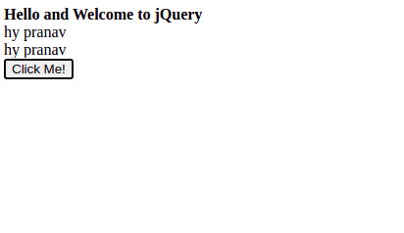

1. Add cross button on row and bind click function which make a delete request to server, after success event remove the row from dom
2. Create a image array and in div create a slide show to animate images of delay of 500ms.

Ans == <https://github.com/pranav0297/jquery/blob/master/jquery17.html>

